

**INSTITUTE FOR ADVANCED COMPUTING AND SOFTWARE DEVELOPMENT**

AKURDI,PUNE – 411044

Documentation On

“Fake News Detection Using ML”

## PG-DBDA AUG 2024

*Submitted by*

**Group No: 09**

**Kshitij Chougale (248523)**

**Sahil Kamble (248540)**

**Dr. Shantanu Pathak Mr. Rohit Puranik**

**Project Guide** **Centre Coordinator**

**DECLARATION**

I, the undersigned hereby declare that the project report titled "Fake News Detection Using ML" written and submitted by me to Institute For Advanced Computing And Software Development Akurdi Pune, in the fulfilment of requirement for the award of degree of Post Graduate Diploma In Big Data Analytics (PG DBDA) under the guidance of Dr. Shantanu Pathak. itis my original work I have not copied any code or content from any source without proper attribution, and I have not allowed anyone else to copy my work. The project was completed using Python and MS Excel and libraries.

The project was developed as part of my academic coursework. I also confirm that the project is original, and it has not been submitted previously for any other academic or professional purpose.

Place: Signature:

Date: Name: Kshitij Chougale Sahil Kamble

**ACKNOWLEDGEMENT**

I would like to express my sincere gratitude to Dr. Shantanu Pathak, Project Guide, for providing me with the guidance and support to complete this academic project. Their valuable insights, expertise, and encouragement have been instrumental in the success of this project. I would also like to thank my fellow classmates for their support and cooperation during the project. Their feedback and suggestions were helpful in improving the quality of the project. I would like to extend my gratitude to Mr. Rohit Puranik, Centre Coordinator, for providing me with the necessary resources and facilities to complete this project. Their support has been crucial in the timely completion of this project.

Finally, I would like to thank my family and friends for their constant encouragement and support throughout the project. Their belief in me has been a constant source of motivation and inspiration. Thank you all for your support and guidance in completing this academic project.

**ABSTRACT**

In the digital age, the rapid spread of misinformation and fake news has become a significant challenge, affecting public perception, politics, and social stability. This project focuses on developing a **Machine Learning (ML)-based Fake News Detection System** that classifies news articles as **real or fake** based on their textual content.

The system utilizes **Natural Language Processing (NLP) techniques** such as **tokenization, stopword removal, and text normalization** to preprocess the dataset. Exploratory Data Analysis (EDA) is performed to identify common linguistic patterns, sentiment trends, and subject distributions between real and fake news articles. For model training, the **Multinomial Naïve Bayes classifier** is used due to its effectiveness in text classification. The model is evaluated using key performance metrics like **accuracy, precision, recall, and F1-score**, achieving an accuracy of approximately **94.86%.**

Additional insights are gathered using **word clouds, sentiment analysis (VADER), and subject-wise news distribution** to understand how misinformation spreads. Future enhancements include **deep learning models (LSTM, BERT), real-time fake news detection, and an expanded dataset** for better accuracy and generalization.

This project provides a **data-driven approach to detecting fake news**, helping to mitigate misinformation by enabling **automated, efficient, and accurate classification** of news articles. The system can be integrated into **fact-checking platforms, media organizations, and social networks** to combat the spread of fake news.

**INDEX**

|  |  |  |
| --- | --- | --- |
| Sr No. | Topic | Page No. |
| 1. | **Chapter 1 Introduction**  1.1Description  1.2 Objective of the project  1.3 Scope of the project  1.4 Limitation of the project | 1-3 |
| 2. | **Chapter 2 Project Description**  2.1 Project work flow diagram  2.2 Data collection  2.3 Studying the data  2.4 Studying the model  2.5 Implementing the model  2.6 Validating the model  2.7 Creating the tool | 4-7 |
| 3. | **Chapter 3 Model Description**  3.1 Important Terms | 8-11 |
| 4. | **Chapter4 Data Flow**  4.1Data flow of project | 12-16 |
| 5. | **Chapter5 Tools used in project**  5.1 Pandas  5.2 Numpy  5.3 Sklearn  5.4 NLTK (Natural Language Toolkit) in Python  5.5 Matplotlib  5.6 Seaborn: Data Visualization in Python  5.7 WordCloud | 17-21 |
| 6. | **Chapter 6 Project Requirements**  6.1 Hardware Requirements  6.2 Software Requirements | 22-23 |
| 7. | **Chapter 7 Future Scope**  7.1 Future Scope | 24-26 |
| 8. | **Chapter 8 Conclusion**  8.1 Conclusion | 27-28 |
| 9. | **Chapter 9 References**  9.1 References | 29-30 |

**­­Chapter 1**

**Introduction**

**Introduction :**

* 1. **Description :**

In today's digital era, the spread of misinformation has become a significant challenge. With the rapid growth of online news platforms and social media, distinguishing between **true** and **fake news** has become increasingly difficult. Misinformation can influence public opinion, affect decision-making, and even cause social and political disruptions.

This project focuses on **fake news detection** using **Natural Language Processing (NLP) and Machine Learning** techniques. The goal is to build a model that can classify news articles as either **"true" or "fake"** based on their textual content. By analyzing word patterns, sentiment, and topic distributions, the project aims to develop an **effective and accurate fake news classifier.**

* 1. **Objectives of the Project :**

1. Develop an Automated Fake News Detection System – Build a machine learning model to classify news as true or fake using NLP techniques.
2. Data Preprocessing – Clean and prepare text data through tokenization, stopword removal, and normalization.
3. Exploratory Data Analysis (EDA) – Identify word patterns, sentiment trends, and subject distributions in fake vs. real news.
4. Model Training & Evaluation – Train a Multinomial Naïve Bayes classifier, assess performance using accuracy, precision, recall, and F1-score.
5. Extract Key Insights – Analyze linguistic characteristics, sentiment, and trends in fake news articles.
   1. **Scope of Project :**

* The Scope of Fake News Detection Using ML include :
* **Text-Based Fake News Detection** – The model analyzes the textual content of news articles to determine if they are true or fake.
* **Dataset Utilization** – The project uses labeled datasets containing true and fake news articles for training and evaluation.
* **Natural Language Processing (NLP)** – Techniques such as tokenization, stopword removal, and word frequency analysis are used to preprocess and analyze text.
* **Machine Learning Classification** – The Multinomial Naïve Bayes classifier is implemented to classify news articles based on word patterns.
* **Exploratory Data Analysis (EDA)** – Insights are gained through word cloud visualization, sentiment analysis, and subject distribution.
* **Model Performance Evaluation** – The classifier’s accuracy is assessed using metrics such as accuracy, precision, recall, F1-score, and a confusion matrix.
  1. **Limitation of Project :**

• **Limited Dataset** – The model's accuracy depends on the quality and diversity of the dataset. If the dataset is biased or outdated, the model may fail to generalize well to new or unseen fake news patterns.

• **Dependence on Textual Features Only** – The system analyzes only the textual content of news articles. It does not consider image, video, or metadata (e.g., source credibility, social media shares), which could enhance detection accuracy.

• **Vulnerability to Adversarial Attacks** – Fake news creators can manipulate text using synonyms, paraphrasing, or obfuscation techniques to bypass detection.

• **Limited Context Understanding** – Traditional ML models like Naïve Bayes rely on word frequency and do not understand sarcasm, hidden meanings, or context as well as deep learning models like BERT or GPT.

• **False Positives & Negatives** – The model may misclassify opinion-based articles, satirical content, or highly controversial news, leading to incorrect predictions.

• **Scalability Issues** – While effective for small to medium datasets, processing large datasets or real-time news streams requires more computational power and optimized deep learning architectures.

• **Lack of Real-Time Fact-Checking** – The system does not cross-check news against verified sources, government fact-checking databases, or real-time news feeds, which could improve credibility assessment.

**Chapter 2**

**Project Description**

**Project Description**

**2.1 Project work flow Diagram :**

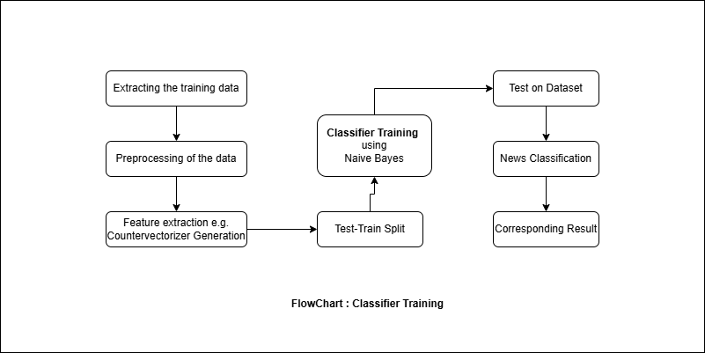

Fig : Project work flow Diagram.

**2.2 Data Collection :**

Effective fake news detection relies on collecting high-quality, diverse datasets. The data collection process includes:

**1. Data Sources**

The dataset for this project is obtained from multiple sources to ensure a mix of true and fake news articles:

* **Kaggle Datasets** – Pre-existing labeled datasets such as the Fake News Dataset and LIAR Dataset.
* **News Websites** – Articles from credible sources like BBC, CNN, The New York Times (for real news).
* **Fact-Checking Websites** – Data from PolitiFact, Snopes, and FactCheck.org to verify misinformation.
* **Social Media & Blogs** – Scraping news articles from Twitter, Facebook, and unreliable blogs to gather fake news samples.

**2. Data Collection Methods**

* **Web Scraping** – Using tools like BeautifulSoup and Scrapy to extract news articles from websites.
* **Publicly Available Datasets** – Importing structured datasets from Kaggle, GitHub, and research repositories.
* **APIs** – Fetching real-time news using APIs like NewsAPI, Google News API, and Twitter API.

**2.3 Studying the Data :**

In this step data collected from NSE website is studied. It is very important to study the data

before using it into the further process. Following are the key findings of data.

Total number of columns: 4

Total number of Numeric columns: 1

Total number of object columns: 3

Total number of date columns: 1

Total number of rows: 45490

**2.4 Studying the Model :**

In this step, a classification model is selected. Multinomial Naïve Bayes (MNB) is chosen for this project as it is widely used for text classification tasks, particularly in Natural Language Processing (NLP). This model works well with word frequency-based features, making it suitable for detecting fake news.

The following are the input parameters of the MNB model:

1. Tokenized and Pre-processed Text Data
2. Bag of Words Representation (CountVectorizer)
3. Labelled Data (Real/Fake News Tags)
4. Train-Test Split Data for Model Training and Evaluation

During the study of the model, it is observed that real and fake news articles exhibit different word patterns and frequencies, which helps the classifier differentiate between them. The Multinomial Naïve Bayes model assumes independence between features and works best with text data converted into numerical form.

**2.5 Implementing the Model :**

The fake news detection model is implemented by preprocessing text data, extracting key features, and applying TF-IDF vectorization. The Multinomial Naïve Bayes algorithm is used to classify news articles as real or fake based on word frequency patterns.

The implementation involves:

1. **Text Preprocessing** – Tokenization, stopword removal, and normalization using NLTK.
2. **Feature Extraction** – Converting text into numerical form using vectorization from **Scikit-Learn**.
3. **Model Training & Prediction** – Training the Naïve Bayes classifier to differentiate between real and fake news.
4. **Performance Evaluation** – Using accuracy, precision, recall, and F1-score to assess model effectiveness.
5. **Deployment** – **Streamlit** is used to build an interactive tool where users can input news articles and get real-time classification results.

**2.6 Validating the Model :**

The effectiveness of the fake news detection model is evaluated using a dataset with known labels (real or fake news). The model's predictions are compared against actual labels to assess its performance.

To measure accuracy, the following evaluation methods are used:

1. **Accuracy Score** – Measures the overall correctness of predictions.
2. **Confusion Matrix** – Displays true positives, true negatives, false positives, and false negatives.
3. **Precision, Recall, and F1-Score** – Determines how well the model identifies fake and real news.
4. **ROC Curve & AUC Score** – Evaluates the trade-off between sensitivity and specificity.

**2.7 Creating the tool :**

The final step involves developing a user-friendly application for fake news detection. The system is deployed using Streamlit, allowing users to input news articles and receive real-time classification results.The tool provides:

1. **Real-Time Analysis** – Users can enter news text, and the model instantly determines if it is real or fake.
2. **Interactive UI** – Designed for ease of use, featuring a simple text input field and a visually appealing output display.
3. **Visualization Charts** – Displays key insights, such as word frequency distribution and sentiment analysis.
4. **Confidence Score** – Shows how confident the model is in its classification.

**Chapter 3**

**Model Description**

**Model Description :**

**3.1 Multinomial Naïve Bayes :**

Multinomial Naïve Bayes is a variant of the Naïve Bayes algorithm used for classification, particularly effective for text classification problems like spam filtering and sentiment analysis. It assumes that features (e.g., word frequencies) follow a multinomial distribution and calculates probabilities based on the frequency of different features in each class. Despite its simplicity, it performs well in high-dimensional spaces, making it popular for natural language processing (NLP) tasks.

**3.2 Important Terms Related to Multinomial Naïve Bayes :**

1. **Naïve Bayes Algorithm**
   * A probabilistic machine learning algorithm based on Bayes’ Theorem.
   * Assumes that features (words in text classification) are conditionally independent, which simplifies calculations.
2. **Multinomial Naïve Bayes (MNB)**
   * A variant of Naïve Bayes used for text classification and discrete feature-based problems.
   * Suitable for document classification where features represent word frequencies.
3. **Bag of Words (BoW) Model**
   * A text representation method where the frequency of words is used as features.
   * Example: “Breaking news! Government announces policy change” → Frequency of each word is counted.
4. **Term Frequency-Inverse Document Frequency (TF-IDF)**
   * A feature extraction technique that gives more weight to important words and less to commonly used words.
   * Formula: TF−IDF=TF×IDFTF-IDF = TF \times IDFTF−IDF=TF×IDF
   * Used in Multinomial Naïve Bayes to improve classification accuracy.
5. **Smoothing Techniques (Laplace / Additive Smoothing)**
   * Used to avoid zero probability when a word is missing from the training data.
   * Formula for Laplace Smoothing: P(w∣c)=(Count(w,c)+1)(Totalwordsinclass+∣Vocabulary∣)P(w|c) = \frac{(Count(w, c) + 1)}{(Total words in class + |Vocabulary|)}P(w∣c)=(Totalwordsinclass+∣Vocabulary∣)(Count(w,c)+1)​
   * Prevents division by zero errors in probability calculations.

**3.3 Multinomial Naïve Bayes Formula :**

Multinomial Naïve Bayes (MNB) is based on Bayes' Theorem and is specifically designed for text classification tasks. It calculates the probability that a document D belongs to a particular class **C** (e.g., Fake or Real news) based on the words it contains.

**1. Bayes’ Theorem (Fundamental Formula)**

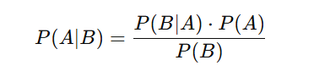

Where:

* + P(AB) = Posterior Probability (Probability of event A occurring given that B has already occurred)
  + P(B|A) = Likelihood (Probability of event B occurring given A is true)
  + P(A) = Prior Probability (Initial probability of event A before considering B)
  + P(B) = Evidence Probability (Total probability of event B occurring)

**2. Multinomial Naïve Bayes Formula**

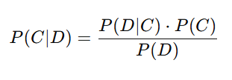

Where:

* + P(CD) = Probability of class C (real or fake) given document D.
  + P(DIC) = Probability of document D given class C.
  + P(C) = Prior probability of class C.
  + . P(D) = Probability of document D occurring in the dataset.

**3.4 Multi nomial Naïve Bayes Assumptions:**

Multinomial Naïve Bayes (MNB) relies on the following key assumptions:

1. **Conditional Independence of Features** – Each feature (e.g., word occurrence in text classification) is assumed to be independent of others, given the class. This simplifies probability calculations but may not hold in real-world scenarios.
2. **Multinomial Distribution of Features** – Features (e.g., words or tokens) follow a multinomial distribution, meaning the model considers the frequency of features in each class rather than just their presence or absence.
3. **Fixed Vocabulary Size** – The model assumes a predefined vocabulary, and only words from this vocabulary are considered when making predictions.
4. **Equal Importance of Features** – Every feature (word/token) is treated equally when determining class probabilities, regardless of contextual relationships.
5. **Presence of All Words in Each Class** (Handled by Smoothing) – Since some words may not appear in certain classes, Laplace (or additive) smoothing is applied to avoid zero probabilities.

**Chapter 4**

**Data Flow**

**4.1 Data Flow of Project :**

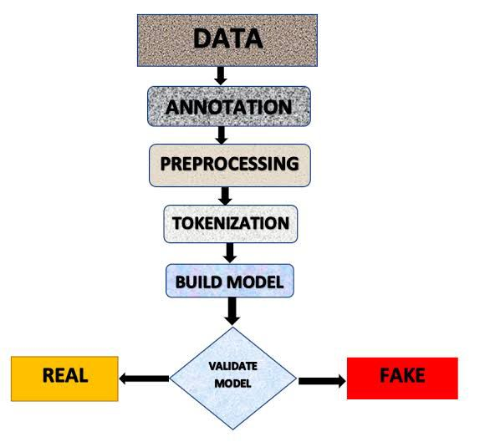

How data is flow in this project is explained here:

The **data flow** in this project follows a structured pipeline, from data collection to final prediction. Below are the key stages:

**1. Data Collection**

* Gather datasets containing true and fake news articles.
* Data sources: Online news repositories, Kaggle datasets, or web-scraped data.
* Each dataset contains title, text, subject, and date of articles.

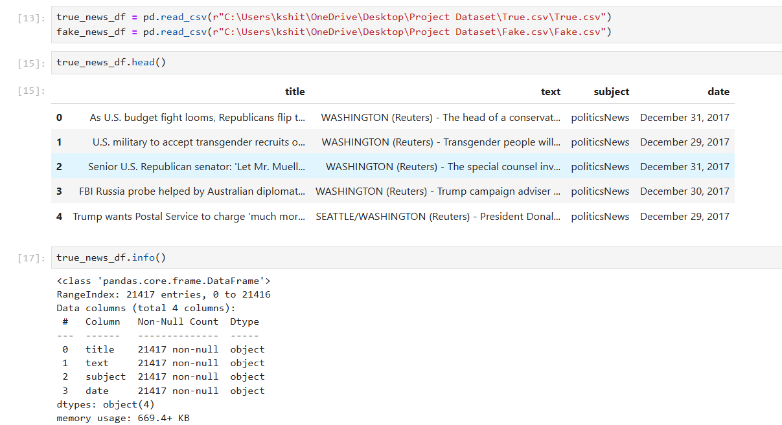

**2. Data Preprocessing**

* **Merging Data:** Combine real and fake news datasets.
* **Removing Duplicates:** Eliminate duplicate or irrelevant records.
* **Handling Missing Values:** Fill or remove missing text fields.
* **Labeling Data:** Assign labels (1 = True News, 0 = Fake News) for classification.
* **Text Cleaning:**
  + Convert text to lowercase.
  + Remove punctuation, numbers, and special characters.
  + Tokenize text (split into words).
  + Remove stopwords (e.g., "the", "is", "and").
  + Lemmatization (convert words to root form, e.g., "running" → "run").

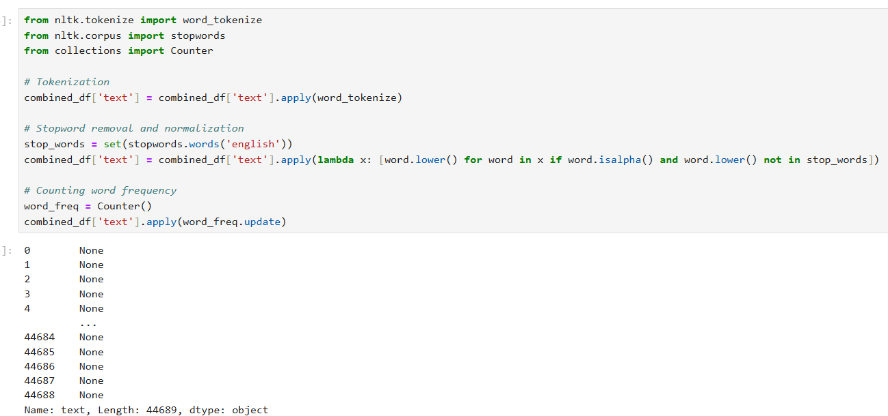

**3. Exploratory Data Analysis (EDA)**

* **Word Frequency Analysis:** Identify most commonly used words.
* **Word Cloud:** Visual representation of frequently occurring words.
* **Sentiment Analysis:** Classify articles as positive, negative, or neutral.
* 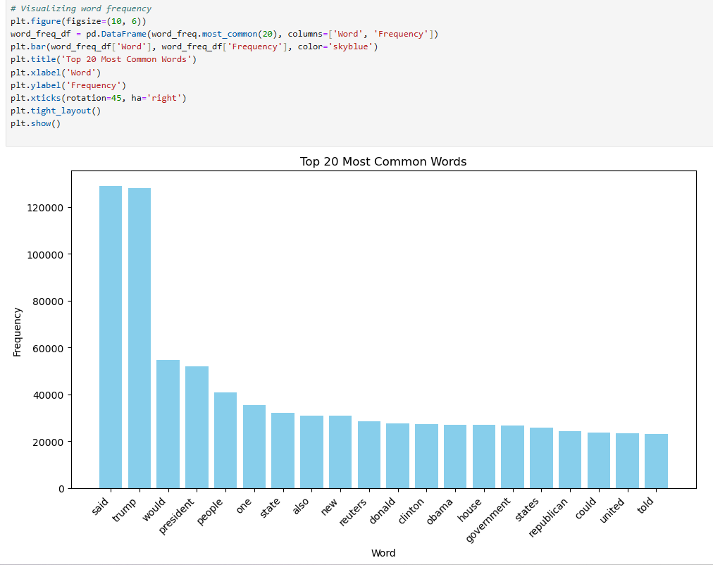**Subject Distribution:** Analyze fake vs. real news across different categories (e.g., politics, sports).

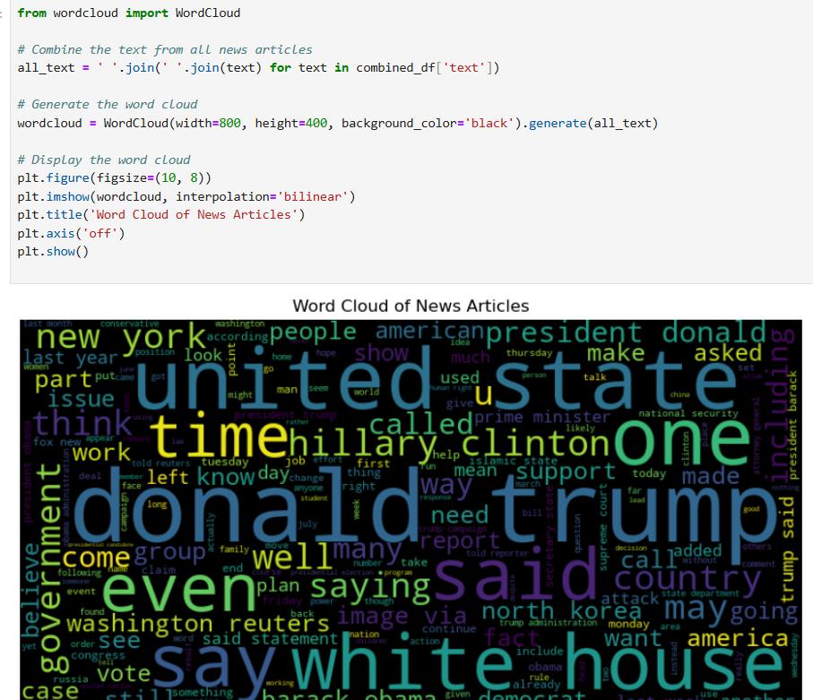

**4. Model Training (Multinomial Naïve Bayes)**

* **Splitting Data:** Divide dataset into training (70%) and testing (30%) sets.
* **Training the Model:** Train the Multinomial Naïve Bayes (MNB) classifier using vectorized text.
* **Adjusting Smoothing (Laplace Smoothing):** Prevents zero probability for unseen words.

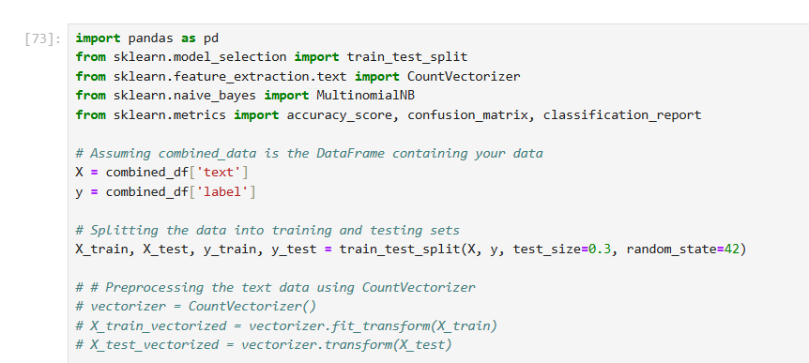

**6. Model Testing & Evaluation**

* **Predictions:** Apply the trained model to unseen test data.
* **Performance Metrics:**
  + **Accuracy:** Percentage of correctly classified articles.
  + **Precision & Recall:** Evaluate false positives and false negatives.
  + **Confusion Matrix:** Visualize model performance.

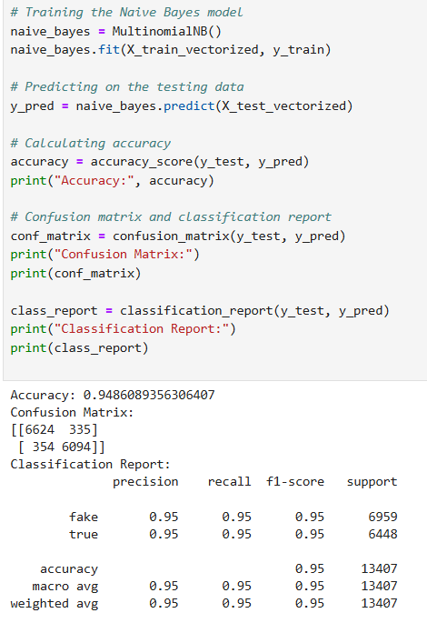

**Chapter 5**

**Tools used in Project**

**Tools used in Project :**

Following libraries are used in project :

**5.1 Pandas :**

Pandas is a popular open-source library for data manipulation and analysis in Python. It was created by Wes McKinney in 2008 and has since become a widely used tool in data science and analytics.

Pandas is built on top of two other Python libraries, NumPy and Matplotlib. NumPy provides efficient numerical operations on arrays of data, while Matplotlib provides powerful visualization tools. Pandas combines these libraries and adds its own data structures and tools to create a comprehensive data analysis package.

One of the key data structures in Pandas is the DataFrame. A DataFrame is a two-dimensional labeled data structure with columns of potentially different types. It can be thought of as a spreadsheet or a SQL table. Each column in a DataFrame is a Series, which is a one-dimensional labeled array that can hold any data type.

Pandas provides a wide range of tools for data cleaning, manipulation, and analysis. Some of the key functions include:

1. Data cleaning: Pandas provides functions for handling missing data, removing duplicates, and converting data types.

2. Data manipulation: Pandas provides functions for merging and joining data, grouping and aggregating data, and pivoting data.

3. Data analysis: Pandas provides functions for statistical analysis, including descriptive statistics, correlation analysis, and hypothesis testing.

4. Time series analysis: Pandas provides functions for working with time series data, including date range generation, resampling, and rolling window calculations

Pandas also provides tools for input/output, including reading and writing data to and from various file formats, such as CSV, Excel, and SQL databases.

Overall, Pandas is a powerful and flexible library for data manipulation and analysis in Python, and it is widely used in the data science community.

**5.2 Numpy:**

NumPy (Numerical Python) is a fundamental library for scientific computing in Python. It provides support for large, multi-dimensional arrays and matrices, along with a vast collection of mathematical functions to operate on these arrays efficiently.

**Key Features:**

1. ndarray (N-dimensional array)
   * Efficient array object for handling large datasets.
   * Faster than Python lists due to fixed-type storage and vectorized operations.
2. Broadcasting
   * Allows arithmetic operations on arrays of different shapes.
3. Universal Functions (ufuncs)
   * Fast element-wise operations (e.g., np.sin(), np.exp()).
4. Linear Algebra & Random Number Generation
   * Built-in functions for matrix multiplication, eigenvalues, etc.
   * Tools for generating probability distributions (e.g., np.random.normal()).
5. Integration with Other Libraries
   * Works seamlessly with Pandas, SciPy, Matplotlib, and machine learning frameworks.

**5.3 Sklearn:**

Scikit-learn (Sklearn) is the most useful and robust library for machine learning in Python. It provides a selection of efficient tools for machine learning and statistical modeling including classification, regression, clustering and dimensionality reduction via a consistence interface in Python. This library, which is largely written in Python, is built upon NumPy. SciPy and Matplotlib.

Scikit-learn (sklearn) is a popular Python library for machine learning. It provides a wide range of functions for model evaluation. Some of the commonly used functions for model evaluation in sklearn are:

1. mean absolute error: This function is used to calculate the mean absolute error between the predicted and actual values for a regression model.

2. mean squared error: This function is used to calculate the mean squared error between the predicted and actual values for a regression model.

3. 12 score: This function is used to calculate the R-squared score for a regression model. The R-squared score is a measure of how well the model fits the data.

These are just some of the commonly used functions for model evaluation in sklearn. Sklearn provides many other functions for model evaluation and selection, depending on the type of problem and the type of model being used.

**5.4 NLTK (Natural Language Toolkit) in Python:**

NLTK is a comprehensive Python library used for working with human language data (text), often referred to as Natural Language Processing (NLP). It provides tools to process, analyze, and understand text, making it essential for text analysis in resume screening projects.

Key Features of NLTK

1. Tokenization – Splitting text into sentences or words.  
2. Text Classification – Classifying resumes based on content or keywords.  
3. Part-of-Speech Tagging – Identifying grammatical parts of sentences.  
4. Named Entity Recognition (NER) – Recognizing entities like names, organizations, and locations in resumes.  
5. Stopword Removal – Removing common words (e.g., "the," "and") that don't add significant meaning.  
6. Stemming & Lemmatization – Reducing words to their base form (e.g., "running" -> "run").  
7. Word Frequency Analysis – Analyzing the frequency of terms for feature extraction.

Using NLTK in Resume Screening

* Text Preprocessing: Tokenizing resume text, removing stopwords, and stemming or lemmatizing words.
* Feature Extraction: Identifying key phrases or skills mentioned in the resumes.
* Categorization: Classifying resumes into relevant job categories or ranking them based on required skills.

NLTK is a valuable library for any NLP-driven task, including resume analysis, where text extraction and processing play a crucial role in automated screening.

**5.5 Matplotlib:**

Matplotlib is a popular data visualization library for Python. It provides a wide range of functions for creating static, animated, and interactive visualizations in Python. Matplotlib is widely used in data science, scientific computing, and engineering applications.

Some of the key features of Matplotlib are:

1. Support for multiple plot types: Matplotlib supports a wide range of plot types, including line plots, scatter plots, bar plots, histogram plots, and many others.

2. Customization options: Matplotlib provides a wide range of customization options for plots. Users can customize the colors, line styles, markers, fonts, axes, labels, and many other aspects of the plot.

3. Integration with other libraries: Matplotlib can be easily integrated with other data analysis libraries in Python, such as NumPy, Pandas, and SciPy.

4. Saving plots in different formats: Matplotlib allows users to save plots in various formats, such as PNG, PDF, SVG, and more.

5. Interactive features: Matplotlib also provides interactive features for plots, such as zooming, panning, and hover tooltips.

6. 3D plotting: Matplotlib provides 3D plotting capabilities, allowing users to create 3D visualizations of data.

Overall, Matplotlib is a powerful and flexible library for data visualization in Python, and it is widely used by data scientists, researchers, and engineers.

**5.6 seaborn:**

Seaborn is a Python data visualization library built on top of Matplotlib. It provides a high-level interface for creating visually appealing and informative statistical graphics. Seaborn integrates well with Pandas and supports complex visualizations like heatmaps, violin plots, and categorical plots with minimal code. It is widely used for exploratory data analysis (EDA) in machine learning projects, including fake news detection. Key features include automatic dataset handling, built-in themes, and enhanced color palettes. Common functions include sns.heatmap() for correlation matrices, sns.countplot() for categorical distributions, and sns.pairplot() for relationship visualization. It simplifies data insights and improves interpretability.

**5.7 word cloud:**

A Word Cloud is a powerful visualization tool used to represent text data, where the size of each word indicates its frequency within the dataset. It is widely used in natural language processing (NLP) and text analysis to identify key terms, patterns, and trends. In the context of fake news detection, word clouds help highlight frequently used words in fake and real news articles, revealing linguistic patterns that may indicate misleading or exaggerated content.

The WordCloud library in Python provides an easy way to generate these visualizations, allowing customization of font size, color schemes, shapes, and background colors. One of the key features of word clouds is their ability to visually emphasize high-frequency words, making it easier to understand dominant themes in large text datasets. Additionally, word clouds can be filtered by removing stopwords (common words like “the,” “and,” “is”) and applying stemming or lemmatization to group similar words together.

By analyzing word clouds for fake and real news articles separately, researchers can identify differences in word choice and sentiment. This insight can be useful in feature selection for machine learning models, helping to improve the accuracy of fake news detection algorithms.

**Chapter 6**

**Project Requirement**

**Project Requirement :**

**6.1 Hardware Requirement:**

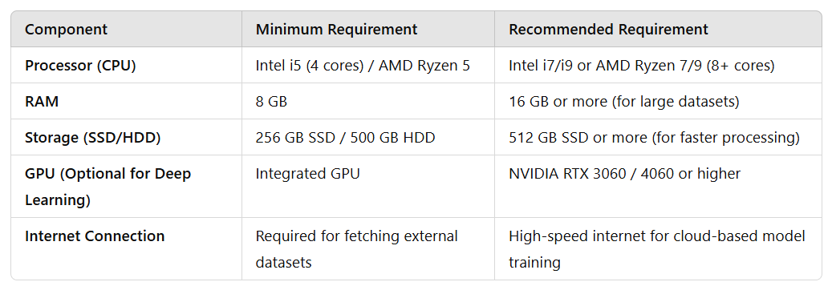

**6.2 Software Requirement:**

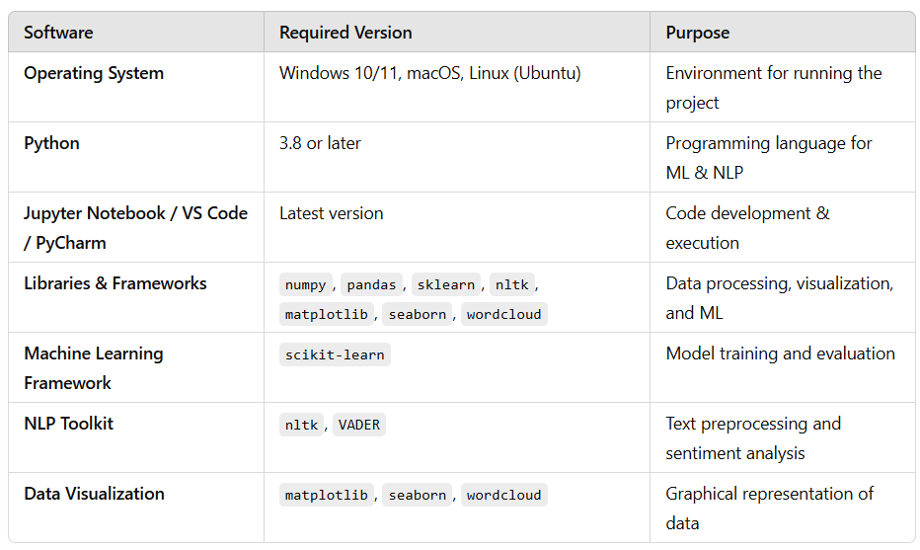

**Chapter 7**

**Future Scope**

**7.1 Future Scope:**

The Fake News Detection project has significant potential for future enhancements and real-world applications. Below are some key areas of improvement:

**1. Improving Model Accuracy**

* **Deep Learning Approaches:** Implement advanced models like LSTM, BERT, or Transformer-based models to improve classification accuracy.
* **Hybrid Models:** Combine Naïve Bayes with neural networks or ensemble learning (Random Forest, XGBoost) for better results.
* **Context Awareness:** Incorporate Natural Language Understanding (NLU) to analyze context, sarcasm, and fake narratives more effectively.

**2. Expanding Dataset & Multilingual Support**

* **Larger Datasets:** Train on larger and more diverse datasets to improve generalization.
* **Multilingual Support:** Extend detection capability to other languages (Hindi, Spanish, French, etc.).
* **Real-Time Data Collection:** Use web scraping and APIs to fetch the latest news for dynamic analysis.

**3. Fact-Checking Integration**

* **Cross-Verification with Trusted Sources:** Compare news articles with verified sources like Reuters, BBC, and government portals.
* **Knowledge Graphs & AI Fact-Checkers:** Use databases like Google Fact Check Explorer to validate news claims.

**4. Deploying as a Web or Mobile Application**

* **Web Application:** Build a real-time fake news detection platform.
* **Mobile App Integration:** Develop an Android/iOS app where users can check the credibility of news articles instantly.
* **Browser Extension:** Create a Chrome/Firefox extension to analyze news credibility while browsing.

**5. Enhancing Fake News Categorization**

* **Misinformation Type Detection:** Classify fake news into categories like propaganda, satire, hoaxes, and biased reporting.
* **Deepfake Detection:** Expand detection to include manipulated images and videos (Deepfake AI analysis).

**6. Social Media & Real-Time Monitoring**

* **Fake News Detection on Social Media:** Analyze posts, tweets, and comments for fake news spread.
* **Sentiment & Virality Analysis:** Identify how fake news spreads and its impact on public opinion.
* **Government & Law Enforcement Use:** Assist cybercrime departments in tracking fake news sources.

**7. Explainable AI for Fake News Detection**

* Implement Explainable AI (XAI) techniques to show why an article is classified as fake or real.
* Help journalists and users understand the reasoning behind AI predictions.

**Chapter 8**

**Conclusion**

**8.1 Conclusion :**

The **Fake News Detection Using Machine Learning** project successfully demonstrates the ability to classify news articles as **real or fake** based on textual content. By leveraging **Natural Language Processing (NLP)** techniques and the **Multinomial Naïve Bayes** algorithm, the model achieves high accuracy in distinguishing between truthful and misleading information.

Through **data preprocessing, exploratory analysis, sentiment detection, and model training,** this project provides an effective approach to combat misinformation. The evaluation metrics indicate that the model performs well, though it can be further improved by incorporating **advanced deep learning techniques, larger datasets, and real-time fact-checking mechanisms.**

In the future, this system can be **enhanced and integrated into web applications, mobile apps, or browser extensions** to provide users with an easy-to-use tool for verifying news credibility. Additionally, expanding its capabilities to detect **multilingual fake news, social media misinformation, and deepfake content** would further strengthen its real-world impact.

This project serves as a **foundation for future research in AI-driven fake news detection,** helping to create a more **informed and reliable digital information ecosystem.**

**Chapter 9**

**References**

**References**

<https://matplotlib.org/stable/index.html>

<https://pandas.pydata.org/docs/>

<https://numpy.org/doc/>

<https://amueller.github.io/word_cloud/generated/wordcloud.WordCloud.html>

<https://seaborn.pydata.org/>

<https://scikit-learn.org/0.21/documentation.html>